

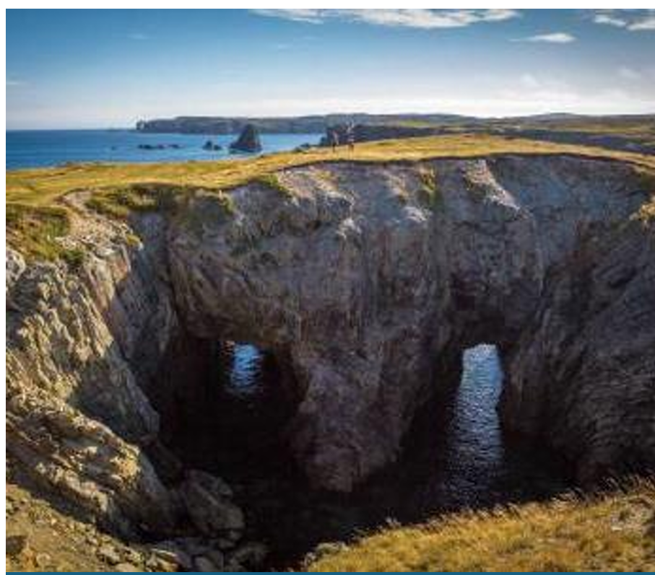

Issued By: Discovery UNESCO Global Geopark Inc.
Tender Number: DUGGp-2025-1
Issue Date: April 23, 2025
Call for Submissions: Discovery Geopark Gateway
Closing Date: May 7, 2025, at 12:00 PM (noon) NST
Notification of Results: No later than May 14, 2025

1. Introduction
Discovery UNESCO Global Geopark Inc. invites qualified and experienced contractors to submit tenders for the civil works at the Discovery Geopark Gateway, located in Southern Bay, NL. This tender covers a range of site preparation and civil works as outlined in the scope below and is to be carried out in accordance with civil and architectural drawings, technical specifications, and relevant codes and standards.

2. Scope of Work
The civil component of the project includes:
- Patch damaged asphalt in areas noted with new asphalt.
- Remove any existing asphalt parking lot lines and paint new lines including an accessible parking space.
- Install accessible parking space signage.
- Complete landscaping as per civil drawings and prepare areas for architectural site features.
- Decommission septic system. Work with power company to ensure proper removal of electrical utilities.
- Remove existing buildings, dilapidated signage and framework.
- Retain existing picnic tables, benches and interpretative signate with bases.
- Coordinate site works with other discipline drawings.
- Complete site works as per drawings, noted specifications and drawing notes.
- Construct Welcome Sign base and mounting structure as per design plan provided. Sign will be provided by Geopark for installation.
- Project updates will be required on request; briefly outlining the activities to date, the remaining work, and other pertinent information as determined through discussions between the Geopark Manager and the selected contractor.
- Note: Water well decommissioning not required at this time. Keep water well in place for future use and emplace/install a non-trip protective covering.

3. Tender Submission Requirements
Interested contractors must submit:
- Company profile and relevant project experience
- Detailed cost Quote and breakdown, valid for a minimum of 14 days after tender opening
- Project schedule and work methodology
- Health & Safety plan
- Insurance and bonding documents
- List of key personnel and subcontractors (if applicable)
- References from comparable completed projects
- The goal of Geopark is to have the project completed by June 30, 2025. In your proposal, please indicate if this is an achievable timeline.

4. Evaluation Criteria
Tenders will be evaluated based on:
- Compliance with submission requirements
- Relevant experience and qualifications
- Proposed project schedule and methodology
- Competitive pricing
- Health and safety practices
- References and prior performance

5. Site Visit & Inquiries
Conduct preliminary site visit for collection of field information in collaboration with Geopark manager.
Suggested / Preferred site visit in collaboration with Geopark Manager as park on bid submission process.
All inquiries regarding this tender must be submitted in writing to:
Geopark Manager
Discovery UNESCO Global Geopark Inc.
Email: manager@discoverygeopark.com
Deadline for questions: May 7, 2025, at 10:00 AM NST

6. Submission Details
Deadline for Submissions:
- May 7, 2025, at 12:00 PM (noon) NST Newfoundland Standard Time
- All tender submissions must be sent electronically via email to:
manager@discoverygeopark.com
- Late submissions will not be accepted.
- Tender proposals will be reviewed during a virtual DUGG Board meeting no later than May 13, 2025, at 7:PM NST.

7. General Terms & Conditions
- Discovery UNESCO Global Geopark Inc. is not bound to accept the lowest or any bid submitted.
- The organization reserves the right to reject any or all tenders, to waive irregularities, and to accept the tender deemed most advantageous for the project.
- All costs incurred by the bidders in the preparation and submission of the tender shall be borne solely by the bidder.
- Successful bidders will be responsible for applying for and obtaining required project permits from regulatory bodies or authorities with relevant jurisdiction.
- The financial value of a contract resulting from this procurement process will be publicly released as part of the award notification process.

- This procurement process is subject to the Access to Information and Protection of Privacy Act, 2015.

- The bidder agrees that any specific information in its bid that may qualify for an exemption from disclosure under subsection 39(1) of the Access to Information and Protection of Privacy Act, 2015 has been identified. If no specific information has been identified it is assumed that, in the opinion of the bidder, there is no specific information that qualifies for an exemption under subsection 39(1) of the Access to Information and Protection of Privacy Act, 2015.

8. Reference Documents
The following documents are provided to support this tender and should be reviewed by all bidders:
- Project Specifications
Bidders are responsible for reviewing these materials in full as part of preparing tender submissions.



Tender Specifications

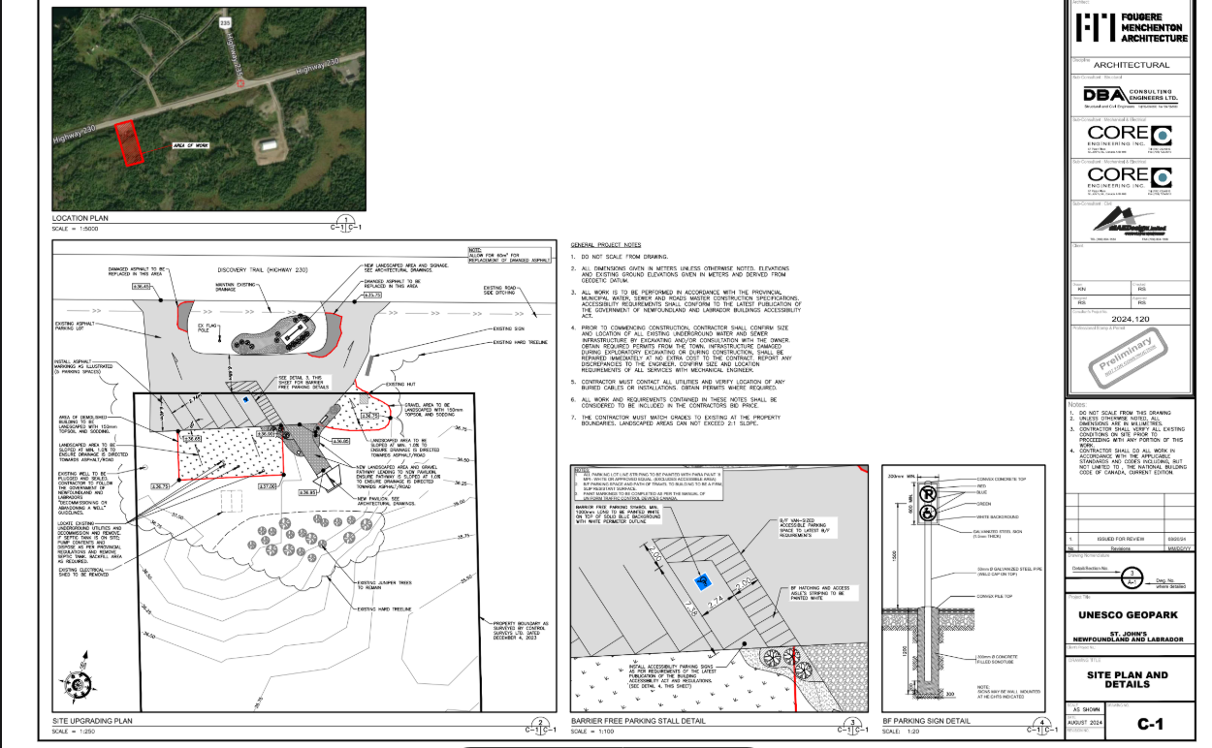
Disregard

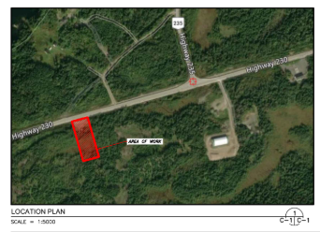
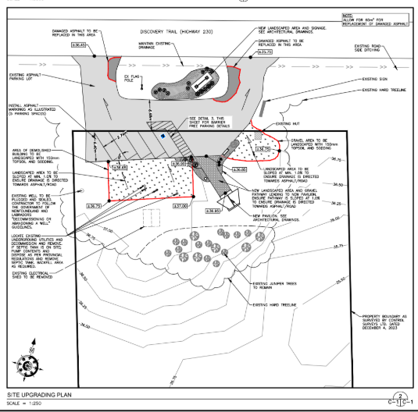
DISREGARD

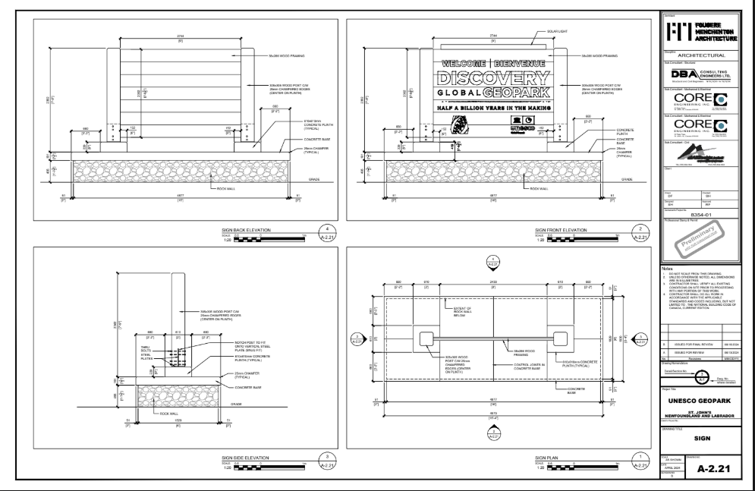
No Electrical Requirement

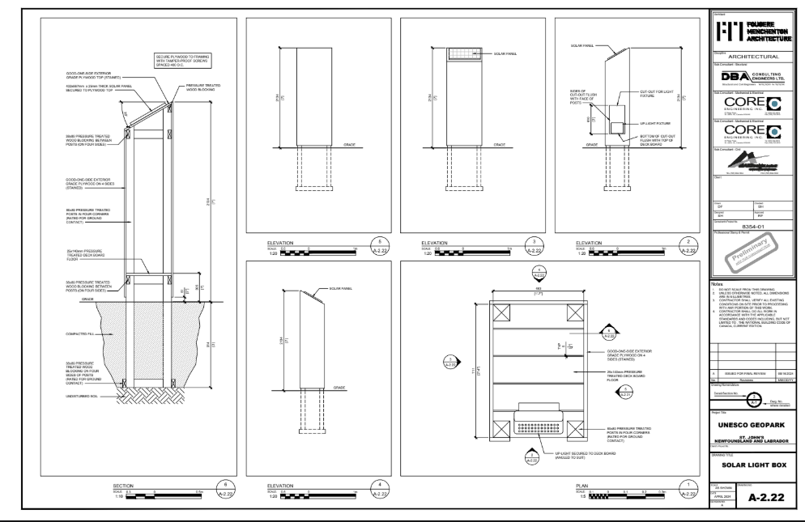
No Electrical Requirement

